DATA ANALYSIS PROJECT REPORT
NCR Ride Bookings
Analyzing Ride-Hailing Booking Patterns, Cancellations, and Revenue Across the National Capital Region (NCR)
🚗
Prepared By | V.Srivani
Organization / Institute | Hanomind Learning
Date | August 2026
Dataset | NCR Ride Bookings (150,000 records)
Tools Used | Python, Pandas, NumPy, Matplotlib, Seaborn
Technologies Used | Jupyter Notebook / VS Code, Microsoft Word

Table of Contents
1. Cover Page 1
2. Executive Summary 3
3. Introduction 5
4. Problem Statement 6
5. Project Objectives 7
6. Dataset Description 8
7. Business Questions 10
8. Tools and Technologies 11
9. Project Workflow 12
10. Data Loading 13
11. Data Exploration 14
12. Data Cleaning 16
13. Exploratory Data Analysis (EDA) — Univariate Analysis 18
14. Bivariate Analysis 22
15. Multivariate Analysis 25
16. Feature Engineering 27
17. Data Visualization 28
18. Business Insights 32
19. Recommendations 33
20. Challenges Faced 34
21. Conclusion 35
22. Future Scope 36
23. References 37

2. Executive Summary
This project analyzes 150,000 ride-booking records from a ride-hailing service operating across the National Capital Region (NCR) of India during the full calendar year 2024. The objective was to understand booking behaviour, identify the causes of ride failures, evaluate revenue and demand patterns, and generate practical recommendations to improve business performance.

Project Objective
To clean, explore, and analyze the NCR ride-booking dataset in order to uncover booking trends, cancellation drivers, revenue patterns, and customer/driver behaviour, and to translate these findings into actionable business recommendations.

Dataset Overview
The dataset contains 150,000 booking records across 21 original columns, covering ride details such as booking status, vehicle type, pickup and drop locations, fare (booking value), ride distance, wait times, ratings, payment method, and cancellation reasons, spanning 1 January 2024 to 30 December 2024.

Analysis Performed
- Data cleaning: removed formatting errors in ID columns, handled missing values, checked duplicates, and engineered date/time features.
- Univariate analysis of booking status, vehicle type, payment method, booking value, and ride distance.
- Bivariate analysis of booking value against vehicle type and ride distance, and cancellation reasons.
- Multivariate analysis using a correlation matrix and grouped pivot summaries across vehicle types.
- Time-based analysis of monthly, daily, and hourly booking demand.

Major Findings
- Only 62% of all bookings (93,000 of 150,000) end in a completed ride; 38% fail due to driver cancellations (18%), no driver being found (7%), customer cancellations (7%), or incomplete trips (6%).
- Driver-initiated cancellations are the single largest cause of ride failure — 2.5 times more frequent than customer cancellations.
- Customers who cancel wait 47% longer on average (12.5 minutes) before cancelling than the average wait time for completed rides (8.5 minutes), showing that long pickup wait times drive customer cancellations.
- Evening hours (5 PM – 8 PM) are the peak demand window, consistent with office commute hours.
- UPI is the dominant payment method (45% of valued rides), reflecting strong digital payment adoption.
- Auto and Go Mini together account for nearly 45% of all bookings, making them the backbone of ride volume and total revenue (₹1.29 crore and ₹1.03 crore respectively).
- The platform generated a total booking value of approximately ₹5.18 crore (₹51,846,183) across completed and valued bookings in the dataset.

Business Value
These findings help the business identify where ride failures originate, which vehicle segments and time windows drive the most revenue, and which operational levers (driver availability, wait-time management, and cancellation-reason mitigation) can most improve completion rates and customer experience.

Final Outcome
The analysis produced a clear, data-backed picture of platform performance in 2024 along with a set of prioritized, actionable recommendations to reduce cancellations, improve driver allocation, and grow revenue — detailed in Sections 18–19 of this report.

3. Introduction
Ride-hailing platforms generate large volumes of transactional data every day — who booked a ride, when, where, in what vehicle, whether the ride was completed, and how much it cost. This project uses one such dataset, covering ride bookings across India's National Capital Region (NCR), to demonstrate a complete, real-world data analysis workflow, from raw data to business recommendations.

What This Project Is About
This project takes a raw CSV file of 150,000 individual ride bookings and turns it into a structured, professional analysis. It covers data cleaning, exploratory data analysis (EDA), visualization, and business insight generation — the same process a data analyst would follow inside a real ride-hailing company.

Why This Analysis Is Important
Ride-hailing is a high-volume, thin-margin business where small improvements in completion rate, driver allocation, or cancellation handling translate into large gains in revenue and customer satisfaction. Understanding exactly where and why rides fail — and which segments generate the most value — is essential to running the business efficiently.

Real-World Business Relevance
- Operations teams can use cancellation and wait-time insights to improve driver dispatch.
- Marketing teams can use demand-pattern insights to plan promotions around peak hours and vehicle types.
- Finance teams can use revenue-by-segment insights to prioritize investment in the most profitable vehicle categories.
- Customer experience teams can use rating and cancellation-reason data to address recurring pain points.

Expected Outcome
A clear, evidence-based understanding of booking behaviour, failure causes, and revenue drivers, presented through visualizations and summarized into practical recommendations that a ride-hailing business could act on.

4. Problem Statement
Ride-hailing platforms lose revenue and customer trust every time a booking fails to convert into a completed ride. In this dataset, 38 out of every 100 bookings do not complete successfully. Without analyzing why, the business has no way to prioritize fixes or measure improvement.

What Business Problem the Dataset Helps Solve
- Identifying which stage of the booking journey (driver assignment, pickup wait, or in-trip) causes the most failures.
- Understanding which vehicle types, locations, and time windows are most and least reliable.
- Quantifying how wait time (VTAT) relates to cancellation behaviour.
- Measuring revenue contribution by vehicle type and payment method to guide business focus.

Why Analyzing This Data Is Useful
Without structured analysis, a business only sees the symptom — lost bookings — not the root cause. Data analysis breaks the 150,000 individual bookings down into patterns that are small enough in number to be understood and large enough in scale to be trusted.

How Organizations Can Benefit
- Reduce driver-initiated cancellations by addressing the most common reasons drivers cancel.
- Reduce customer-initiated cancellations by shortening pickup wait times in high-cancellation zones.
- Allocate more drivers to high-demand vehicle types and peak hours.
- Improve overall completion rate, which directly increases revenue without needing more bookings.

5. Project Objectives
- Understand the structure, size, and content of the NCR ride-booking dataset.
- Clean the dataset by fixing formatting issues, handling missing values, and checking for duplicates.
- Explore booking status, vehicle type, payment method, and other categorical patterns.
- Perform univariate, bivariate, and multivariate exploratory data analysis (EDA).
- Create meaningful, business-relevant visualizations for every key variable.
- Generate insights that are fully supported by the data — no assumptions.
- Provide practical, actionable recommendations for improving business outcomes.

6. Dataset Description
Field | Value
Dataset Name | NCR Ride Bookings
Dataset Source | User-provided CSV file (ride-hailing booking transactions)
Number of Rows | 150,000
Number of Columns (original) | 21
Number of Columns (after feature engineering) | 26 (5 date/time features added)
Time Period Covered | 1 January 2024 – 30 December 2024
Geography | National Capital Region (NCR), India

Column-by-Column Description
Column | Description | Type
Date | Date of the booking (2024-01-01 to 2024-12-30) | Date/Time
Time | Time of day the booking was made | Date/Time
Booking ID | Unique identifier for each booking (e.g. CNR5884300) | Text
Booking Status | Outcome of the booking: Completed, Cancelled by Driver, Cancelled by Customer, No Driver Found, Incomplete | Categorical
Customer ID | Unique identifier for each customer (e.g. CID1982111) | Text
Vehicle Type | Type of vehicle booked: Auto, Bike, eBike, Go Mini, Go Sedan, Premier Sedan, Uber XL | Categorical
Pickup Location | Named pickup location (176 unique locations) | Categorical
Drop Location | Named drop-off location (176 unique locations) | Categorical
Avg VTAT | Average Vehicle Turn-Around Time — minutes for the driver to reach pickup | Numerical
Avg CTAT | Average Customer Turn-Around Time — total trip duration in minutes | Numerical
Cancelled Rides by Customer | Flag (1) marking a customer-cancelled ride | Numerical (flag)
Reason for cancelling by Customer | Customer's stated cancellation reason | Categorical
Cancelled Rides by Driver | Flag (1) marking a driver-cancelled ride | Numerical (flag)
Driver Cancellation Reason | Driver's stated cancellation reason | Categorical
Incomplete Rides | Flag (1) marking an incomplete ride | Numerical (flag)
Incomplete Rides Reason | Reason the ride could not be completed | Categorical
Booking Value | Fare value of the booking in ₹ (Indian Rupees) | Numerical
Ride Distance | Trip distance in kilometres | Numerical
Driver Ratings | Rating given to the driver (3.0–5.0) | Numerical
Customer Rating | Rating given to the customer (3.0–5.0) | Numerical
Payment Method | UPI, Cash, Credit Card, Debit Card, or Uber Wallet | Categorical

7. Business Questions
The following business questions can be directly answered using the fields available in this dataset:
- What share of bookings are completed versus cancelled or incomplete, and which failure type dominates?
- Which vehicle types are booked most often, and which generate the most revenue?
- Which payment method do customers prefer?
- What are the most common reasons customers and drivers cancel rides?
- Is there a relationship between pickup wait time (Avg VTAT) and customer cancellations?
- What time of day and day of week see the highest ride demand?
- Are there monthly/seasonal trends in booking volume across the year?
- Which pickup and drop locations are busiest?
- How do driver ratings compare with customer ratings on average?
- Is booking value related to ride distance or vehicle type?
Questions that cannot be reliably answered from this dataset — such as individual driver identity, exact GPS routes, traffic conditions, or profitability after operating costs — are intentionally excluded, since the data does not support them.

8. Tools and Technologies
Tool | Purpose | Real-World Use
Python | Core programming language for the entire analysis | Industry-standard language for data analytics and automation
Pandas | Loading, cleaning, and transforming tabular data | Used to filter, group, and summarize millions of rows of business data
NumPy | Numerical operations and array-based calculations | Powers fast statistical computation behind Pandas and ML libraries
Matplotlib | Creating static charts (bar, line, scatter, histogram) | Standard plotting library used in almost every Python data report
Seaborn | Statistical visualizations with cleaner default styling | Used for quick, presentation-ready charts like heatmaps and box plots
Jupyter Notebook / VS Code | Interactive coding environment for step-by-step analysis | Lets analysts write code, view results, and document findings together

9. Project Workflow
The analysis followed a standard, linear data-analysis workflow, shown below. Each stage builds on the previous one, ensuring that every conclusion is traceable back to the raw data.
Step | What Was Done
Problem Statement | Defined the business problem: understanding why bookings fail and how to improve revenue.
Dataset Collection | Received the NCR Ride Bookings CSV file containing 150,000 booking records.
Import Libraries | Loaded Pandas, NumPy, Matplotlib, and Seaborn into the Python environment.
Load Dataset | Read the CSV file into a Pandas DataFrame for analysis.
Data Exploration | Checked shape, column names, data types, and summary statistics.
Data Cleaning | Fixed ID formatting, handled missing values, checked for duplicates.
Exploratory Data Analysis | Examined every column's distribution and relationships.
Univariate Analysis | Studied each variable individually (booking status, vehicle type, value, etc.).
Bivariate Analysis | Compared two variables at a time, e.g. booking value vs vehicle type.
Multivariate Analysis | Built a correlation matrix and grouped pivot summaries across several fields.
Feature Engineering | Created Month, Day of Week, and Hour columns from the raw date/time fields.
Data Visualization | Built 16 charts covering distributions, trends, and comparisons.
Business Insights | Converted statistical findings into plain-English business insights.
Recommendations | Proposed concrete actions the business could take based on the insights.
Conclusion | Summarized the overall findings and business value of the analysis.

10. Data Loading

Importing Libraries
Before working with any data, the required Python libraries were imported: Pandas (for tabular data), NumPy (for numerical operations), and Matplotlib/Seaborn (for charts).

Reading the Dataset
The CSV file was read into Python using pandas.read_csv(). The text value "null" appearing in the file was explicitly told to Pandas to treat as a missing value (NaN), since it was stored as plain text rather than a true empty cell.

The DataFrame Concept
A DataFrame is Pandas' core data structure — think of it as a spreadsheet inside Python, made of rows and columns, where each column can hold a different type of data (numbers, text, or dates) and every row represents one ride booking.

Displaying the Dataset
The first few rows were viewed using df.head() to visually confirm that the data loaded correctly and that column names and values looked as expected.

Verifying Successful Loading
The dataset's shape confirmed 150,000 rows and 21 original columns, matching the size of the raw CSV file, which verified that no rows were lost or corrupted during loading.

11. Data Exploration
Before cleaning or analyzing the data, it is important to understand its basic shape and structure. Each function below is documented with its purpose, syntax, output, and business interpretation, in beginner-friendly terms.

df.head()
Purpose: Shows the first 5 rows of the dataset
Syntax: df.head()
Output: A quick preview of 5 sample bookings with all 21 columns
Business Interpretation: Confirms the data loaded correctly and gives a first look at real records

df.tail()
Purpose: Shows the last 5 rows of the dataset
Syntax: df.tail()
Output: The final 5 bookings in the file (dated late December 2024)
Business Interpretation: Confirms the dataset is complete and not cut off

df.shape
Purpose: Returns (rows, columns) as a tuple
Syntax: df.shape
Output: (150000, 21)
Business Interpretation: Confirms the dataset scale — 150,000 individual bookings to analyze

df.columns
Purpose: Lists all column names
Syntax: df.columns
Output: All 21 field names, e.g. Booking Status, Vehicle Type, Booking Value
Business Interpretation: Confirms which business fields are available for analysis

df.dtypes
Purpose: Shows the data type of every column
Syntax: df.dtypes
Output: Text (object) columns for IDs/categories, float64 for numeric fields
Business Interpretation: Flags columns that may need type conversion, e.g. Date

df.info()
Purpose: Summarizes columns, non-null counts, and memory usage
Syntax: df.info()
Output: Confirms 150,000 entries and reveals which columns have missing values
Business Interpretation: Immediately shows where cancellation/rating data is naturally sparse

df.describe()
Purpose: Generates summary statistics for numeric columns
Syntax: df.describe()
Output: Mean, min, max, quartiles for Booking Value, Ride Distance, Ratings, etc.
Business Interpretation: Gives a fast statistical snapshot of pricing, distance, and rating ranges

12. Data Cleaning

Fixing Malformed ID Columns
Why it is required: Booking ID and Customer ID were stored with extra quotation marks (e.g. "CNR5884300" appeared as """CNR5884300""" in the raw file) due to a CSV export issue.
Method used: Used Python string stripping (.str.strip('"')) to remove the extra quote characters from both columns.
Advantage: IDs are now clean and usable for joins, filtering, and duplicate checks.
Limitation: This is a formatting fix only — it does not change or validate the underlying ID values themselves.
Business impact: Clean IDs are essential if this data is ever joined with other systems (e.g. driver payment records).

Handling Missing Values
Why it is required: Columns like Booking Value, Ride Distance, and Ratings are missing for rides that never completed — this is expected, not an error.
Method used: Missing values were left as NaN rather than filled in, since a ride that was cancelled genuinely has no fare, distance, or rating. Analyses of these columns were restricted to rows where the data exists.
Advantage: Preserves the true meaning of the data — a cancelled ride should not be given a fake fare or rating.
Limitation: Reduces the sample size available for fare/distance/rating analysis to the ~93,000–102,000 relevant rows.
Business impact: Prevents misleading averages that would occur if missing values were incorrectly treated as zero.

Checking for Duplicate Rows
Why it is required: Duplicate rows can inflate booking counts and distort every downstream statistic.
Method used: Used df.duplicated().sum() to check for fully duplicated rows across all columns.
Advantage: Confirms whether the raw data is safe to analyze as-is.
Limitation: A full-row duplicate check will not catch duplicate Booking IDs that have different other values (see below).
Business impact: No fully duplicate rows were found, so no rows needed to be removed on this basis.

Checking Duplicate Booking IDs
Why it is required: Since Booking ID should uniquely identify a transaction, repeated IDs point to a data-quality issue worth flagging.
Method used: Counted repeated values in the cleaned Booking ID column.
Advantage: Surfaces potential double-counted bookings for the business to investigate.
Limitation: Without a system log, it cannot be determined whether these are true duplicates or a coincidental ID-generation issue.
Business impact: 1,233 duplicate Booking IDs were found (about 0.8% of records) — flagged as a data-quality issue for the source system team, not removed, since row-level data still differs.

Correcting Data Types
Why it is required: The Date column was stored as plain text, which prevents time-based sorting, filtering, and trend analysis.
Method used: Converted Date to a proper datetime type using pandas.to_datetime(), and combined Date and Time into a single Datetime field.
Advantage: Enables month, day-of-week, and hour-based analysis.
Limitation: Relies on the original text format being consistent, which it was in this dataset.
Business impact: Made all time-based trend analysis (Sections 13 and 17) possible.

Removing Extra Whitespace
Why it is required: Leading/trailing spaces in text columns can cause identical-looking categories to be treated as different values.
Method used: Applied .str.strip() across all text columns.
Advantage: Ensures accurate grouping and counting of categorical values like Vehicle Type and Payment Method.
Limitation: Does not fix inconsistent capitalization or spelling — none was found in this dataset upon inspection.
Business impact: Guarantees that counts like '37,419 Auto bookings' are not artificially split across near-duplicate labels.

Outlier Review
Why it is required: Extreme values in Booking Value or Ride Distance could distort averages.
Method used: Reviewed the minimum, maximum, and quartile ranges via df.describe(). Booking Value ranged from ₹50 to ₹4,277 and Ride Distance from 1 km to 50 km — both plausible ranges for city rides.
Advantage: Confirms the numeric fields do not contain impossible values (e.g. negative fares or zero-distance rides).
Limitation: A statistical outlier check does not confirm real-world accuracy, only internal consistency.
Business impact: No values needed to be removed or capped; the data range is business-plausible.

13. Exploratory Data Analysis (EDA) — Univariate Analysis

Numerical Columns
Statistic | Booking Value (₹) | Ride Distance (km) | Driver Rating | Customer Rating
Mean | 508.30 | 24.64 | 4.23 | 4.40
Median | 414.00 | 23.72 | 4.30 | 4.50
Minimum | 50.00 | 1.00 | 3.00 | 3.00
Maximum | 4,277.00 | 50.00 | 5.00 | 5.00
Std. Deviation | 395.81 | 14.00 | 0.44 | 0.44
25th Percentile (Q1) | 234.00 | 12.46 | - | -
75th Percentile (Q3) | 689.00 | 36.82 | - | -

Business Meaning
- The median Booking Value (₹414) is well below the mean (₹508), meaning a small number of high-value long rides pull the average upward — most rides are moderately priced.
- Ride Distance is fairly evenly spread between 1 km and 50 km, indicating the platform serves both short local trips and long cross-city journeys.
- Both Driver and Customer Ratings cluster tightly between 4.0 and 5.0, with Customer Ratings (4.40 average) running slightly higher than Driver Ratings (4.23 average).

Booking Value Distribution
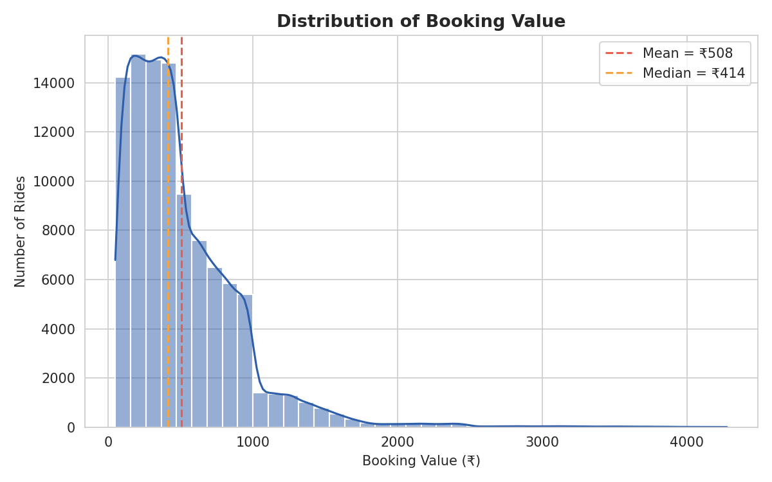
Figure 13.1 — Distribution of Booking Value, showing a right-skewed pattern typical of fare data.

Ride Distance Distribution
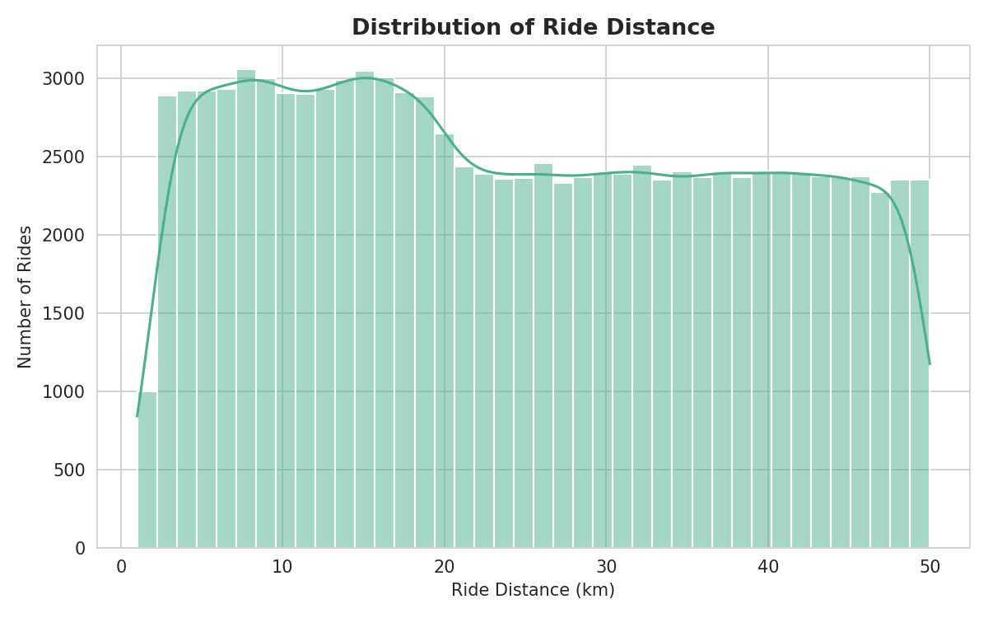
Figure 13.2 — Distribution of Ride Distance across all valued bookings.

Categorical Columns — Frequency and Percentage

Booking Status
Status | Count | Percentage
Completed | 93,000 | 62.0%
Cancelled by Driver | 27,000 | 18.0%
No Driver Found | 10,500 | 7.0%
Cancelled by Customer | 10,500 | 7.0%
Incomplete | 9,000 | 6.0%
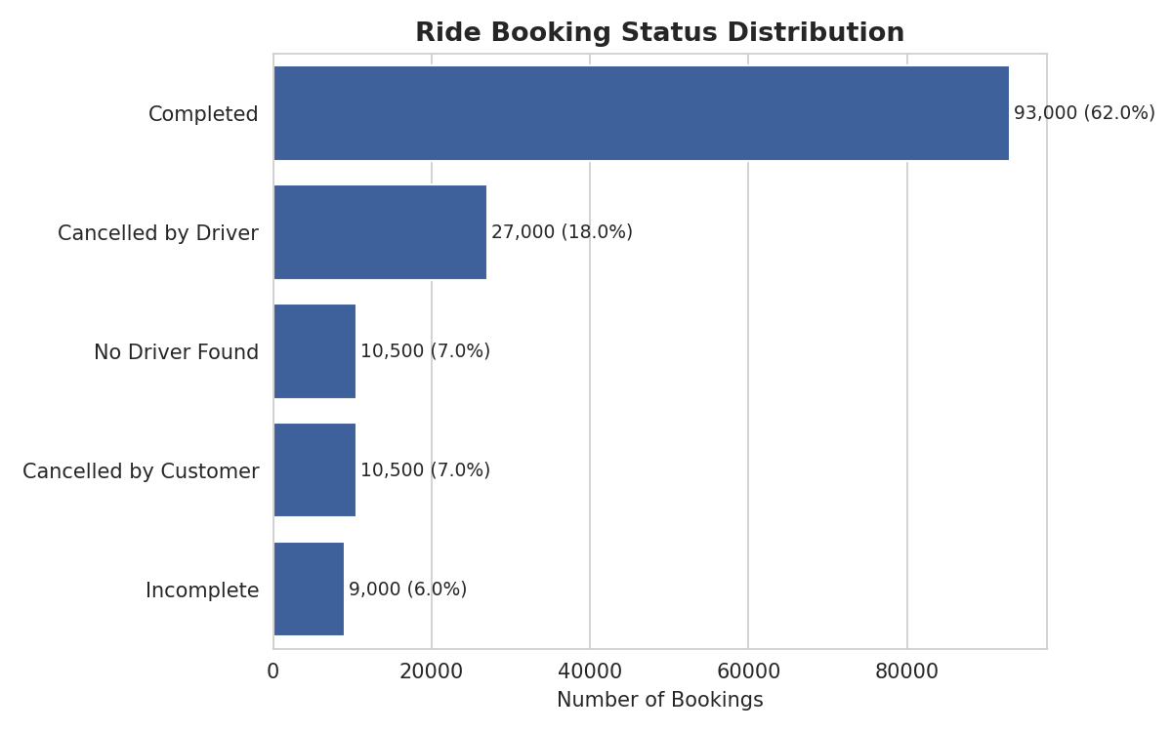
Figure 13.3 — Ride Booking Status Distribution.

Vehicle Type
Vehicle Type | Count | Percentage
Auto | 37,419 | 25.0%
Go Mini | 29,806 | 19.9%
Go Sedan | 27,141 | 18.1%
Bike | 22,517 | 15.0%
Premier Sedan | 18,111 | 12.1%
eBike | 10,557 | 7.0%
Uber XL | 4,449 | 3.0%
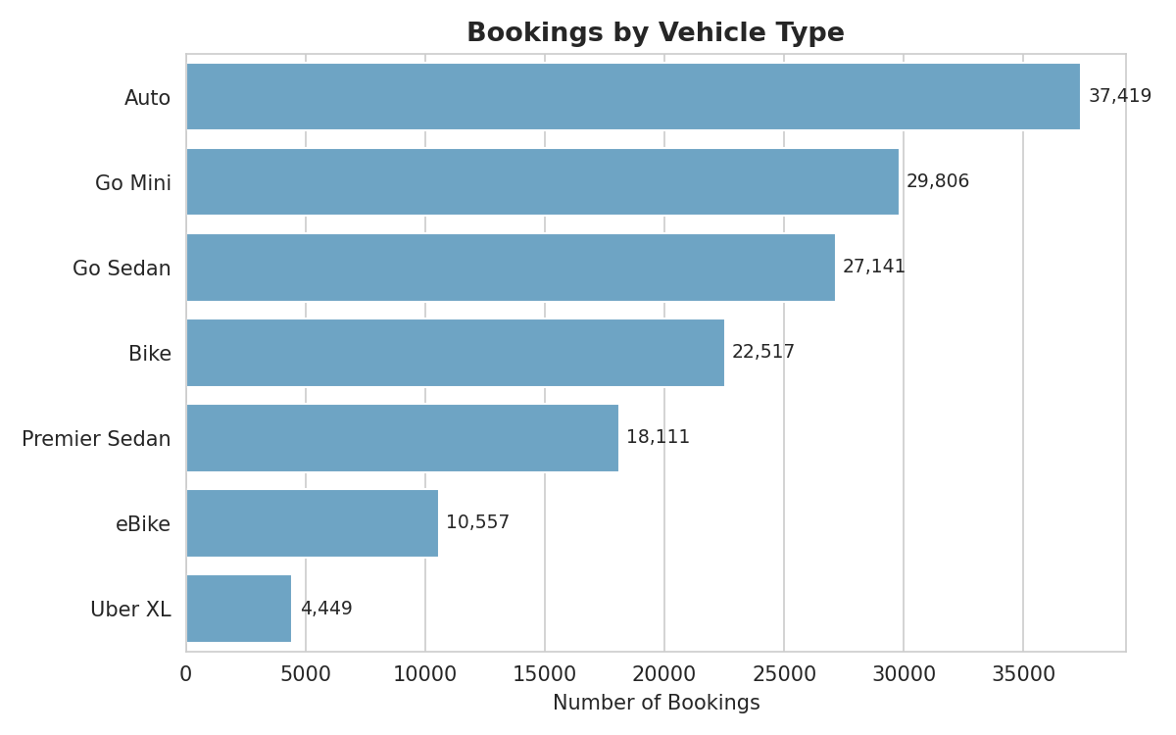
Figure 13.4 — Bookings by Vehicle Type. Auto is the most-booked vehicle category.

Payment Method
Payment Method | Count | Percentage
UPI | 45,909 | 45.0%
Cash | 25,367 | 24.9%
Uber Wallet | 12,276 | 12.0%
Credit Card | 10,209 | 10.0%
Debit Card | 8,239 | 8.1%
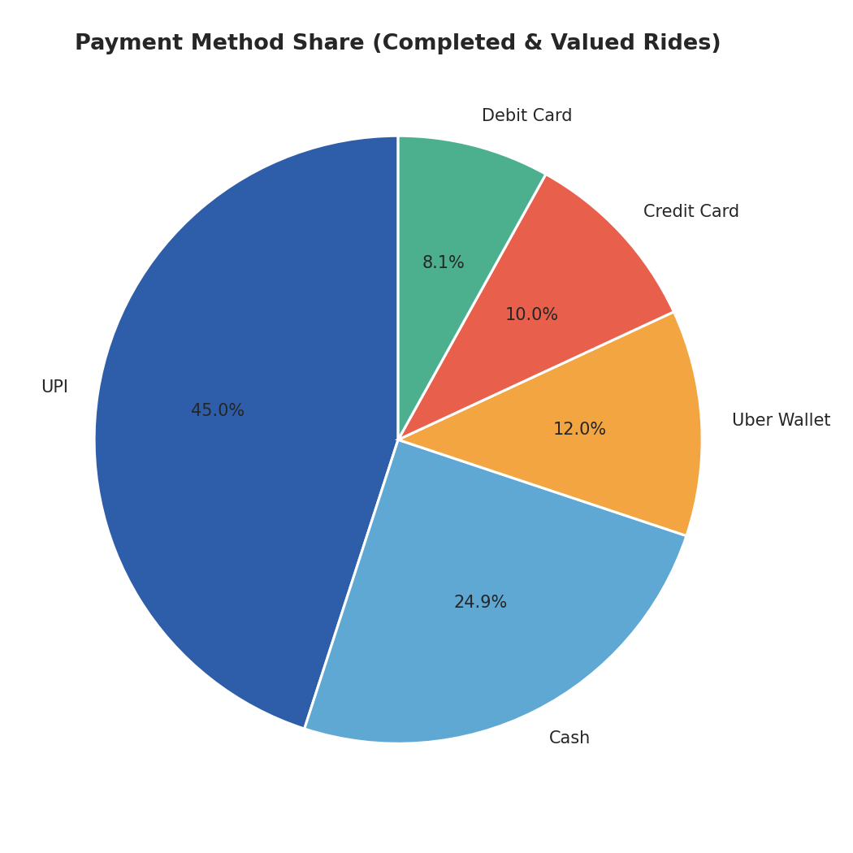
Figure 13.5 — Payment Method Share among valued bookings.
Business meaning: UPI's dominance (45%) confirms strong digital-payment adoption, while Cash still holds a meaningful 25% share, suggesting the platform should keep supporting both digital and cash options for now.

14. Bivariate Analysis

Booking Value by Vehicle Type
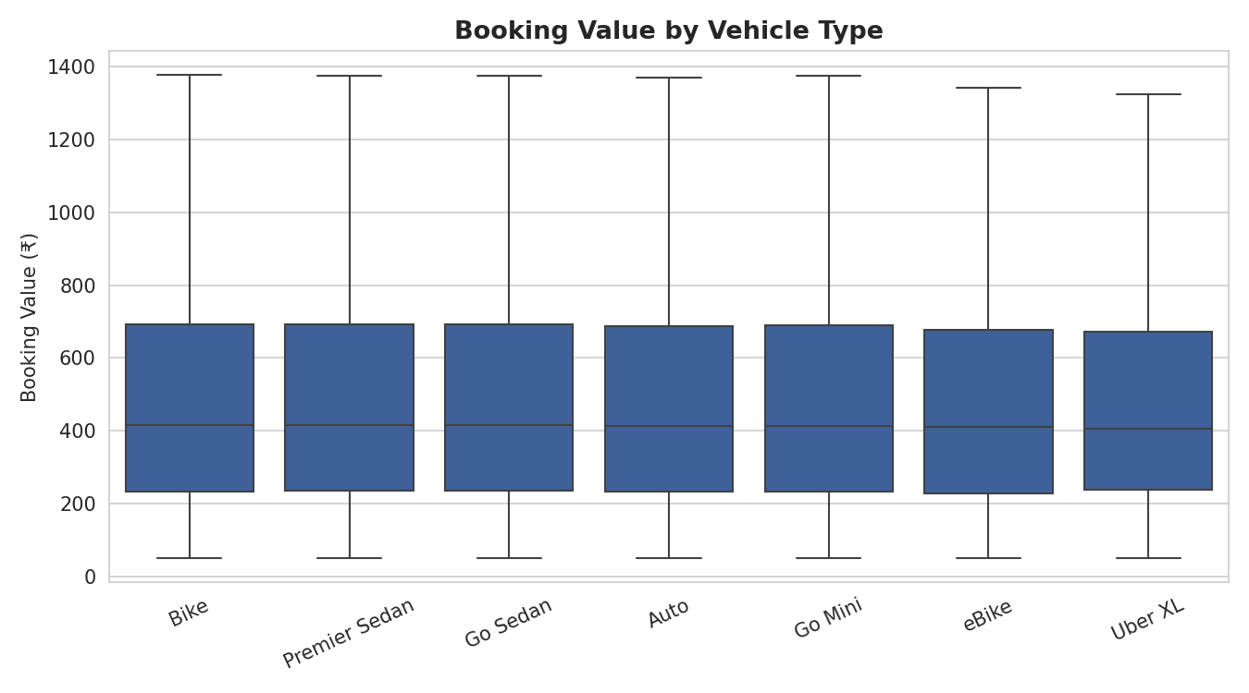
Figure 14.1 — Booking Value distribution across Vehicle Types (box plot, outliers hidden for clarity).
Relationship: Median booking value is broadly similar across vehicle types (₹502–₹512 on average), with Go Sedan and Bike slightly higher and Uber XL slightly lower.
Trend: There is no dramatic price separation between premium (Premier Sedan, Uber XL) and economy (Auto, Bike) categories in this dataset.
Business interpretation: Vehicle type alone does not strongly predict fare — trip distance and duration likely play a bigger role, suggesting fare bundling may be relatively flat across vehicle classes.

Ride Distance vs Booking Value
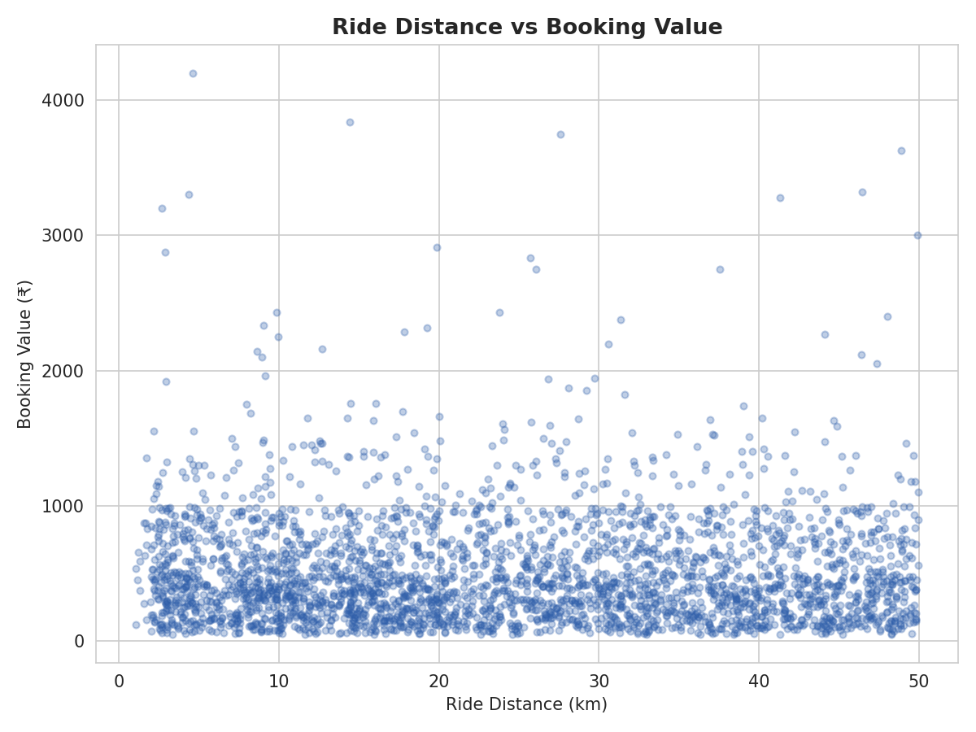
Figure 14.2 — Scatter plot of Ride Distance against Booking Value (3,000-point sample for readability).
Relationship: The scatter shows a wide, diffuse cloud with no clear upward line.
Trend: Longer rides do not consistently cost more in this dataset — the correlation between distance and value is effectively zero (see Section 15).
Business interpretation: This is worth flagging to the business — if real-world pricing should scale with distance, this pattern suggests either a flat/zone-based fare structure or a data-generation limitation that merits validation against the live pricing engine.

Cancellation Reasons by Customer
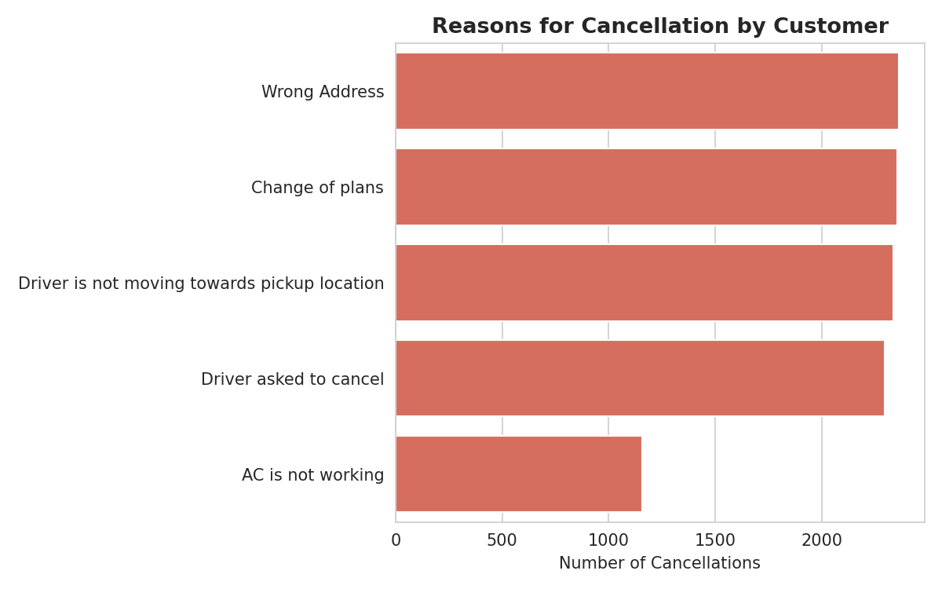
Figure 14.3 — Reasons customers gave for cancelling a ride.
Relationship: Wrong Address (2,362) and Change of Plans (2,353) are the top two customer-side reasons, closely followed by driver not moving towards pickup (2,335) and driver asked to cancel (2,295).
Business interpretation: Nearly half of customer cancellations (4,630 of 10,500) are driver-related (not moving towards pickup, or asked to cancel) rather than customer-related — meaning the customer's cancellation is often really a symptom of a driver-side problem.

Cancellation Reasons by Driver
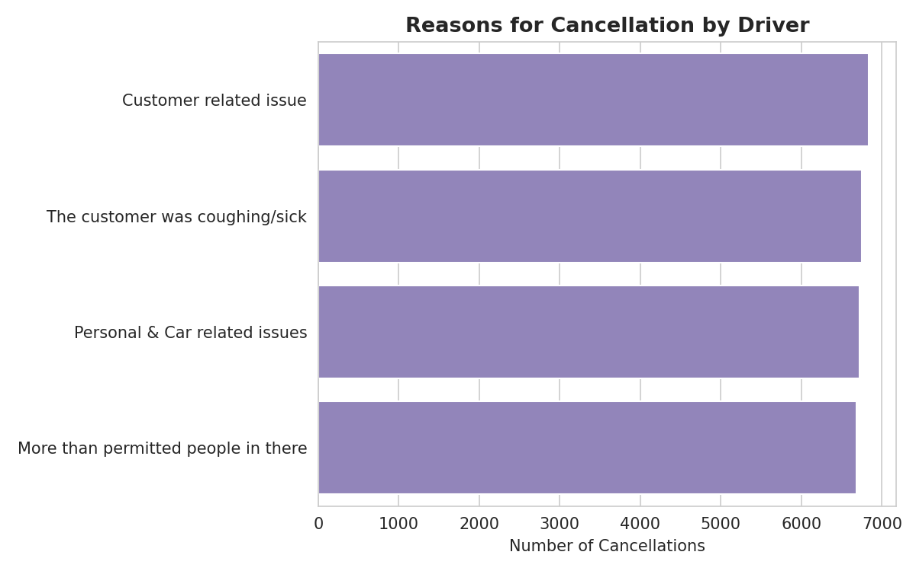
Figure 14.4 — Reasons drivers gave for cancelling a ride.
Relationship: The four driver cancellation reasons are almost evenly split — Customer related issue (6,837), Customer coughing/sick (6,751), Personal & Car related issues (6,726), and More than permitted people (6,686).
Business interpretation: Driver cancellations are spread across customer-behaviour issues and vehicle/personal issues in roughly equal measure — no single reason dominates, so fixing this requires multiple parallel interventions rather than one quick fix.

15. Multivariate Analysis

Correlation Matrix
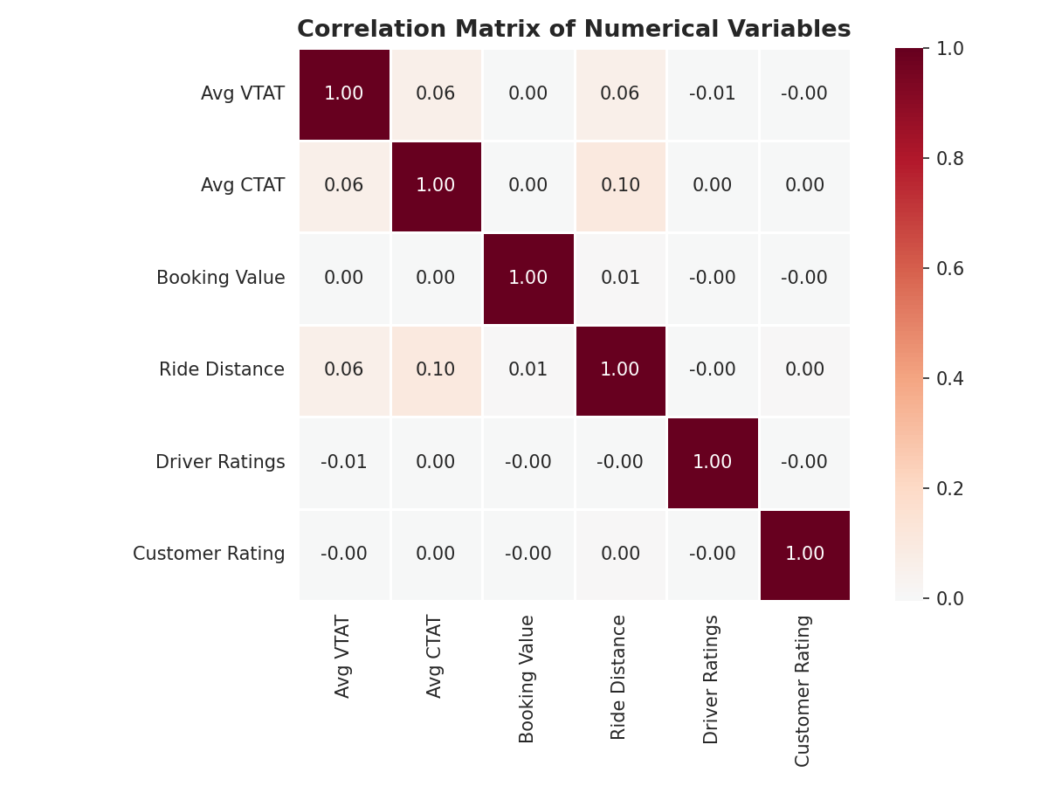
Figure 15.1 — Correlation matrix of key numerical variables.
Findings: Every pairwise correlation among Avg VTAT, Avg CTAT, Booking Value, Ride Distance, Driver Ratings, and Customer Rating is close to zero (between -0.01 and 0.10). This means none of these numeric fields move together in any strong, predictable way — for example, a longer ride distance does not reliably mean a higher fare or a lower rating in this dataset.

Pivot Table — Completion Rate by Vehicle Type
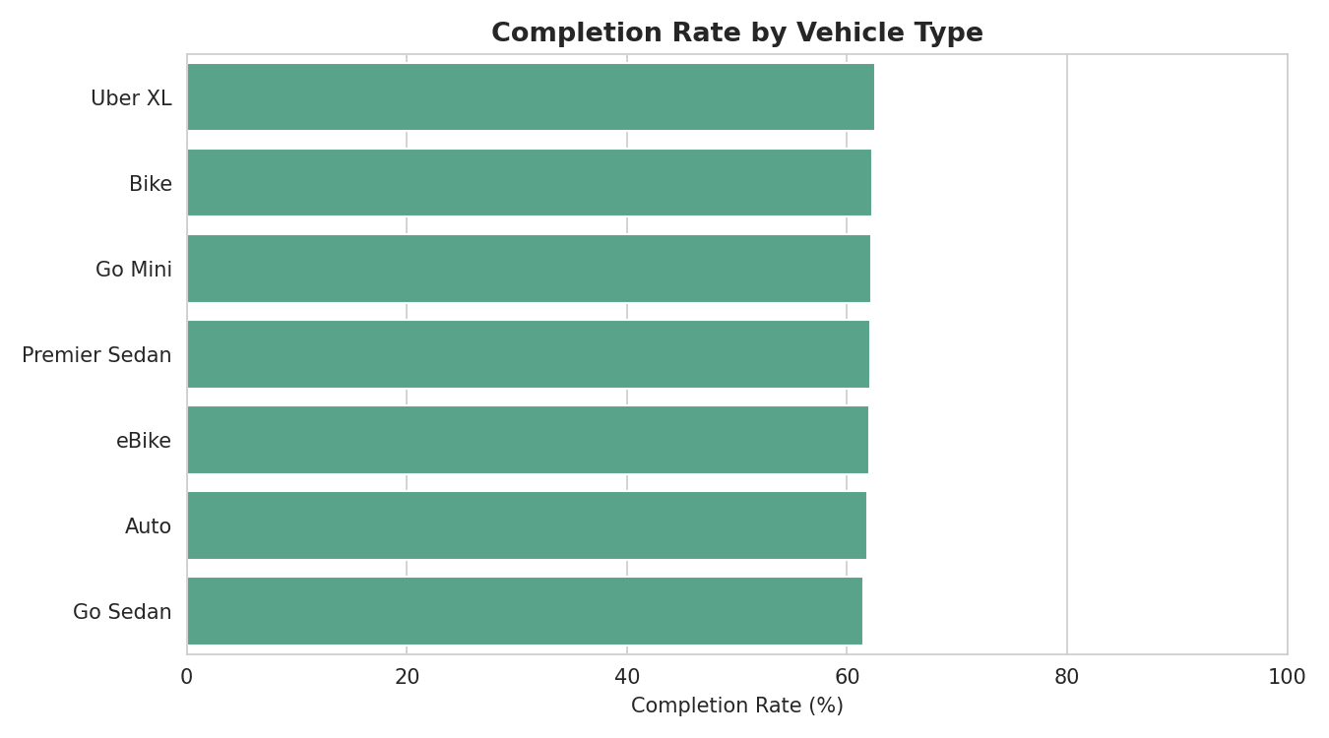
Figure 15.2 — Ride completion rate (%) by Vehicle Type.

Vehicle Type | Completion Rate
Uber XL | 62.6%
Bike | 62.3%
Go Mini | 62.2%
Premier Sedan | 62.1%
eBike | 62.1%
Auto | 61.9%
Go Sedan | 61.4%
Findings: Completion rate is remarkably consistent across vehicle types (61.4%–62.6%), meaning ride failure is not concentrated in any one vehicle category — it is a platform-wide issue rather than a vehicle-specific one.

GroupBy Analysis — Wait Time by Booking Outcome
Booking Status | Average Wait Time (Avg VTAT, minutes)
Cancelled by Customer | 12.51
Completed | 8.51
Cancelled by Driver | 7.50
Incomplete | 6.01
This is one of the most important findings in the analysis: bookings that customers cancel have an average pickup wait time of 12.51 minutes — 47% longer than the 8.51-minute average for completed rides. This strongly suggests that long driver-arrival wait times are a key driver of customer-side cancellations.

GroupBy Analysis — Revenue by Vehicle Type
Vehicle Type | Total Revenue (₹) | Share of Total Revenue
Auto | 1,28,78,422 | 24.8%
Go Mini | 1,03,38,496 | 19.9%
Go Sedan | 93,69,719 | 18.1%
Bike | 78,37,697 | 15.1%
Premier Sedan | 62,75,332 | 12.1%
eBike | 36,18,485 | 7.0%
Uber XL | 15,28,032 | 2.9%
Findings: Auto alone contributes nearly a quarter of total platform revenue (₹1.29 crore of ₹5.18 crore total) due to its high booking volume, even though its average fare is not the highest — confirming that volume, not price per ride, drives Auto's revenue leadership.

16. Feature Engineering
The raw dataset only provided separate Date and Time text columns. To enable time-based analysis, the following new columns were created:
New Feature | How It Was Created | Business Benefit
Date time | Combined Date and Time into a single, proper date time value | Enables precise chronological sorting and time-window filtering
Month | Extracted the calendar month name from Date | Enables monthly seasonality analysis (Section 17)
Day Of Week | Extracted the day name (Monday–Sunday) from Date | Reveals weekday vs weekend demand patterns
Hour | Extracted the hour (0–23) from Time | Identifies peak and off-peak demand hours for driver allocation
No other derived fields were created, since the existing columns (Booking Status, Vehicle Type, Payment Method, etc.) already provided clean, directly usable categories for analysis without needing further transformation.

17. Data Visualization

Monthly Booking Trend
Chart Title: Monthly Ride Booking Trend (2024)
Objective: To check whether ride demand is seasonal or steady across the year.
Why this chart was selected: A line chart clearly shows the shape of a trend over ordered time periods.
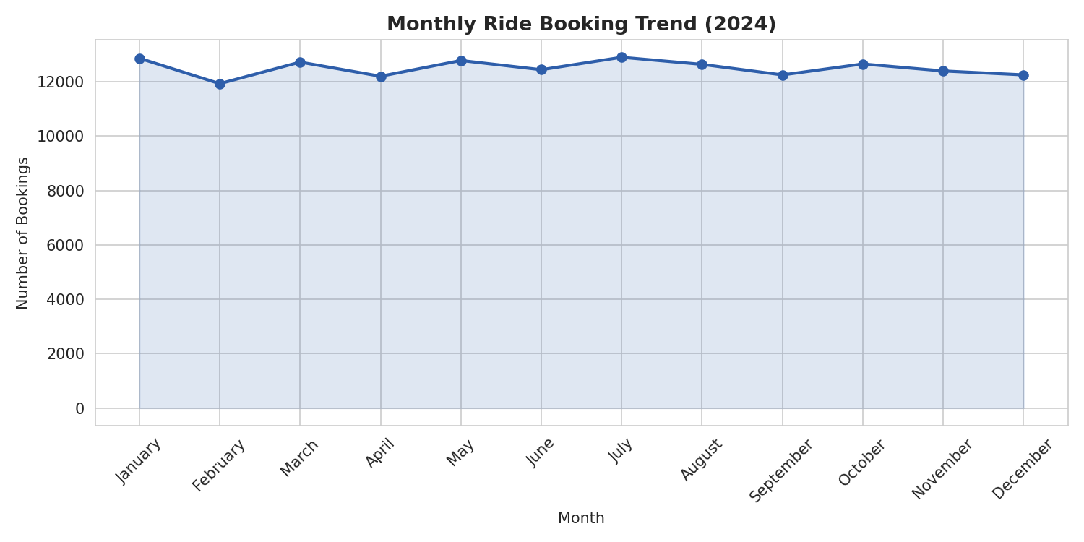
Figure 17.1 — Monthly booking volume across 2024.
Observation: Booking volume is fairly stable across all 12 months, ranging narrowly, with July (12,897), January (12,861), and May (12,778) as the highest months.
Business interpretation: Demand is not strongly seasonal in this dataset, so the business can plan driver capacity fairly evenly across the year rather than over-investing in any single season.

Ride Demand by Hour of Day
Chart Title: Ride Demand by Hour of Day
Objective: To identify peak and low-demand hours for driver scheduling.
Why this chart was selected: A bar chart makes it easy to compare 24 discrete hourly buckets at a glance.
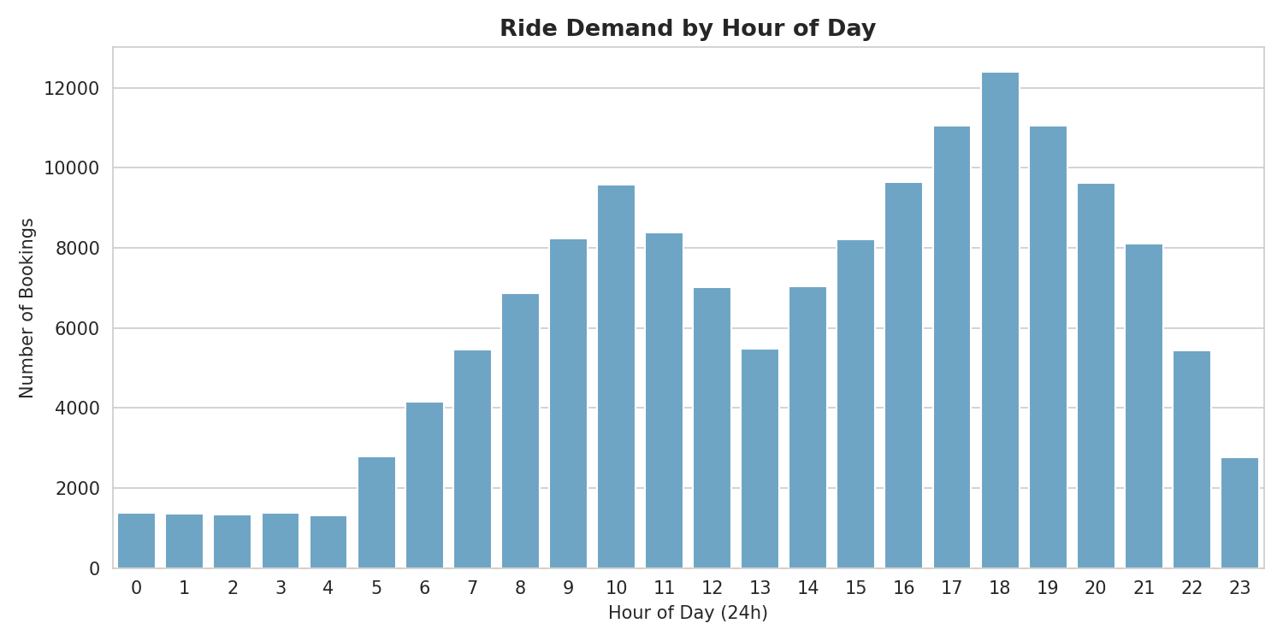
Figure 17.2 — Ride bookings by hour of day (24-hour format).
Observation: Demand rises steadily through the day and peaks sharply between 5 PM and 8 PM, led by 6 PM (12,397 bookings) — classic evening commute behaviour.
Business interpretation: The business should prioritize driver availability and surge-readiness in the 5–8 PM window, when both demand and the risk of 'No Driver Found' bookings are highest.

Ride Demand by Day of Week
Chart Title: Ride Demand by Day of Week
Objective: To see whether weekdays or weekends drive more bookings.
Why this chart was selected: A bar chart clearly compares seven ordered weekday categories.
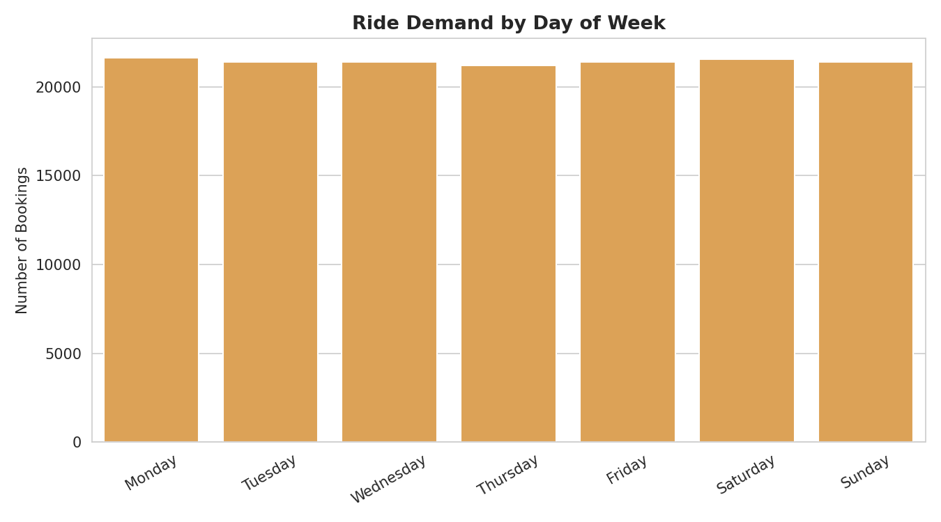
Figure 17.3 — Ride bookings by day of week.
Observation: Booking volume is broadly even across all seven days, without a sharp weekday/weekend divide.
Business interpretation: Unlike many commute-driven services, this platform sees consistent demand every day of the week, suggesting a broad, non-commute-only customer base.

Top Pickup Locations
Chart Title: Top 10 Pickup Locations
Objective: To identify which locations generate the most pickup demand.
Why this chart was selected: A horizontal bar chart ranks locations clearly by volume.
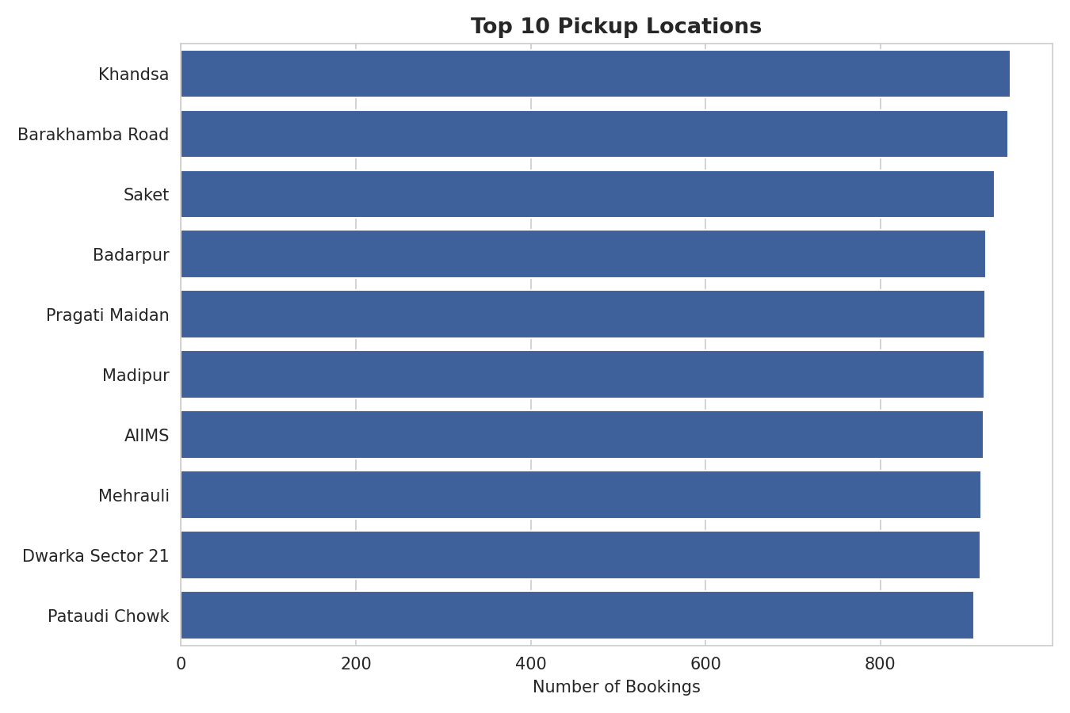
Figure 17.4 — Top 10 pickup locations by booking count.
Observation: Demand is spread relatively evenly across the top locations, with Khandsa (949), Barakhamba Road (946), and Saket (931) leading — no single location dominates.
Business interpretation: With 176 pickup locations and fairly even demand, the business likely needs broad city-wide driver coverage rather than concentrating drivers in just a few hotspots.

Driver Ratings vs Customer Ratings
Chart Title: Driver Ratings vs Customer Ratings Distribution
Objective: To compare how drivers and customers rate each other.
Why this chart was selected: Overlaid density curves make it easy to compare two rating distributions directly.
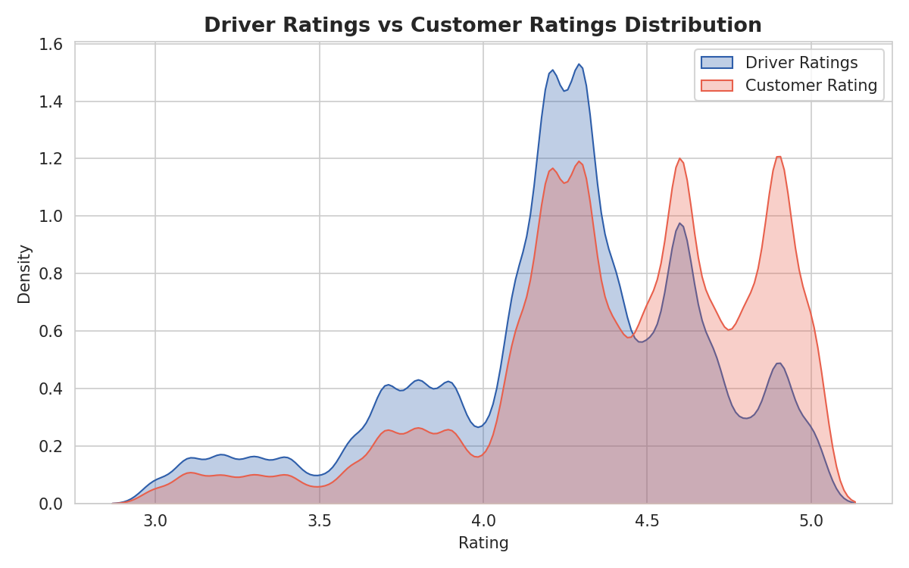
Figure 17.5 — Distribution of Driver Ratings and Customer Ratings.
Observation: Customer Ratings (mean 4.40) skew slightly higher than Driver Ratings (mean 4.23), and both are concentrated between 4.0 and 5.0.
Business interpretation: Drivers are rated marginally more critically than customers, which may be worth monitoring if it affects driver retention or morale over time.

18. Business Insights
- Only 62% of bookings complete successfully — a 38% failure rate represents a large, addressable revenue opportunity.
- Driver-initiated cancellations (18% of all bookings) are the single biggest cause of ride failure, well ahead of customer cancellations (7%) and 'No Driver Found' (7%).
- Long pickup wait time is strongly linked to customer cancellations: cancelled-by-customer bookings had a 12.51-minute average wait versus 8.51 minutes for completed rides.
- Nearly half of stated customer cancellation reasons are actually driver-caused (driver not moving towards pickup, or driver asked to cancel), meaning the true 'customer cancellation' problem is partly a driver-behaviour problem.
- Evening hours (5–8 PM) are the clear demand peak, mirroring typical urban commute patterns.
- Booking demand is stable across months and days of the week, showing no strong seasonal or weekday/weekend swings.
- Auto and Go Mini together generate close to 45% of total bookings and are the largest revenue contributors, led by volume rather than higher per-ride pricing.
- UPI is the clear preferred payment method (45%), with Cash still significant (25%), showing a mixed digital/cash payment landscape.
- Ride distance and vehicle type show almost no correlation with booking value, driver rating, or customer rating — pricing and satisfaction appear largely independent of trip length in this dataset.
- Repeat bookings from the same customer are rare within the year (only 1,206 of 148,788 customers booked more than once, max 3 times) — most demand comes from largely one-time riders in this dataset.

19. Recommendations

1. Reduce driver-initiated cancellations
Why suggested: Driver cancellations (18%) are the largest single cause of ride failure, more than double the customer cancellation rate.
Expected business benefit: Even a modest reduction in driver cancellations would directly raise the completion rate above 62%, increasing realized revenue without acquiring a single new customer.

2. Shorten pickup wait times, especially before they exceed ~10 minutes
Why suggested: Customer cancellations occur at a 47% longer average wait time (12.51 vs 8.51 minutes) than completed rides, pointing to a clear wait-time threshold that triggers cancellations.
Expected business benefit: Faster driver assignment in the first 10 minutes could meaningfully cut the 7% customer-cancellation rate.

3. Increase driver availability during the 5 PM – 8 PM peak window
Why suggested: This window sees the highest booking volume of the day, which likely also strains driver supply and worsens both wait times and 'No Driver Found' outcomes.
Expected business benefit: Better peak-hour coverage should simultaneously reduce cancellations and no-driver-found bookings, capturing more of the day's highest-demand revenue.

4. Investigate the flat relationship between distance and fare
Why suggested: Ride Distance shows almost no correlation with Booking Value, which is unusual for a distance-based pricing model and could indicate either a genuine flat/zone pricing structure or a pricing-engine issue worth validating.
Expected business benefit: Ensuring fares scale appropriately with distance protects margins on longer trips and fairness for shorter ones.

5. Address the top four driver cancellation reasons directly
Why suggested: 'Customer related issue', 'customer coughing/sick', 'personal & car issues', and 'more than permitted people' are almost equally common, so no single fix will resolve driver cancellations.
Expected business benefit: Targeted policies — such as clearer passenger-count guidance, driver wellness support, and stricter no-show/behaviour reporting — could each chip away at a meaningful share of the 27,000 driver cancellations.

6. Build a repeat-customer loyalty strategy
Why suggested: Only about 0.8% of customers booked more than once in the year, suggesting weak repeat engagement.
Expected business benefit: Even a small improvement in repeat-ride rate would grow revenue from the existing customer base at a lower cost than acquiring new riders.

20. Challenges Faced
- Missing values: Booking Value, Ride Distance, and Ratings were missing for a large share of rows (32%–41%) because these fields naturally only exist for completed rides — this had to be handled carefully to avoid misleading averages.
- Data quality issues: Booking ID and Customer ID contained extra quotation-mark characters from the original CSV export, requiring a cleaning step before the IDs could be used reliably.
- Duplicate Booking IDs: 1,233 Booking IDs appeared more than once; without access to the source system, it could not be determined with certainty whether these were true duplicate transactions or a coincidental ID-generation pattern.
- Weak correlations: Nearly all numeric variables (distance, value, wait time, ratings) showed close-to-zero correlation with each other, which limited how much predictive insight could be drawn from the multivariate analysis.
- Limited feature depth: The dataset does not include driver identity, GPS routes, surge pricing flags, or operating costs, which constrained the analysis to booking-level patterns rather than deeper operational or profitability analysis.

21. Conclusion
This project analyzed 150,000 ride bookings from the NCR ride-hailing dataset covering all of 2024. After cleaning the data and engineering time-based features, the analysis examined booking outcomes, vehicle and payment preferences, cancellation causes, demand timing, and revenue distribution.
The clearest finding is that 38% of all bookings fail to complete, driven mainly by driver cancellations and, to a lesser extent, long pickup wait times that push customers to cancel. Demand is heavily concentrated in the 5–8 PM evening window but is otherwise stable across months and days of the week. Auto and Go Mini vehicles, together with UPI payments, dominate platform activity.
These findings carry clear business value: they point to specific, addressable levers — faster driver assignment, peak-hour driver allocation, and targeted cancellation-reason interventions — that could raise the completion rate and grow revenue without requiring new customer acquisition. The final outcome of this project is a data-backed diagnosis of where the platform is losing bookings and a prioritized set of recommendations to address it.

22. Future Scope
- Dashboard creation: Build a live dashboard (e.g. in Power BI or Tableau) so operations teams can monitor completion rate, cancellations, and demand hotspots in real time.
- Machine learning models: Train a classification model to predict, at booking time, the probability that a ride will be cancelled — enabling proactive driver reassignment.
- Predictive analytics: Forecast hourly and location-level demand to guide dynamic driver positioning ahead of peak periods.
- Recommendation systems: Suggest optimal vehicle types or pickup adjustments to customers in high-cancellation zones.
- Automation: Automatically flag bookings whose wait time exceeds the 10-minute cancellation-risk threshold identified in this analysis, triggering a driver-reassignment workflow.
- Real-time reporting: Extend this static, point-in-time analysis into a continuously updated reporting pipeline as new booking data arrives.

23. References
- Dataset Source: User-provided CSV file — NCR Ride Bookings, 150,000 records (2024).
- Python Documentation — https://docs.python.org/3/
- Pandas Documentation — https://pandas.pydata.org/docs/
- NumPy Documentation — https://numpy.org/doc/
- Matplotlib Documentation — https://matplotlib.org/stable/index.html
- Seaborn Documentation — https://seaborn.pydata.org/

